During the second quarter of the Rams-Bucs 2022 NFC Divisional Round, with the Rams leading 20-3, on the NBC broadcast, Cris Collinsworth said “The Rams have the better team, but the Bucs have Tom Brady.” However, he failed to mention that for the game to be closer, the Buccaneers defense would need to prevent the Rams from scoring, something Brady has no control of. This is the narrative prevalent throughout Tom Brady’s career. Despite his poor performances in the postseason, his teams have always played well enough to win. Tom Brady’s statistics are objectively worse than other quarterbacks. He is additionally praised as someone who is a great post-season performer. However, Brady is a good regular season performer, but an average postseason quarterback who profits from his team’s success.
The Super Bowl is a team award. While quarterbacks are important to a team’s success, football is the epitome of a team sport and the Super Bowl should be regarded as a team award. In a paper about Positional Correlation values, written by Steven Vu, the lack of impact of a QB on an NFL team can be seen. Based on Correlation Coefficients and R-squared values, there is a larger impact in team success from other positions than QB, like Offensive Linemen, Running Backs, Wide Receivers, and Tight Ends. There are hundreds of Hall of Fame caliber players and coaches that Brady has worked with that are not acknowledged for their contributions to Tom Brady’s win. The only argument made for Tom Brady’s “GOAT” status is his Super Bowl rings, not because of his performances or statistics. He should not be declared as “the best” because of team accomplishments. While it is impossible to say how well Brady would play with another franchise, or how other quarterbacks would perform in his position, there is definitive data that indicates other quarterbacks perform better than him and are more crucial to team success than him. Tom Brady plays quarterback in the National Football League. He does not play cornerback, wide receiver, defensive edge, or on special teams. His impact comes from his role as the quarterback and when his defense or special teams play incredibly well and the team wins, somehow the credit is given mostly to Brady. Obviously, this is an extreme, but if he threw an interception every single pass attempt, his team could still win the game if the other 52 rostered players play well.
In the regular season, Tom Brady has a 63.8% completion %, 3.02 TD/INT, 97.0 passer rating, 5.4 TD%, and 1.8 INT%. Solid numbers for sure. However, his stats get worse in the postseason, posting a 63% completion %, 2.09 TD/INT, 89.8 passer rating, 4.5 TD%, and 2.2 INT%. He has worse numbers in each statistic and yet the main narrative is that Tom Brady is this amazing postseason performer. In his 6 Super Bowl playoffs with the Patriots, Tom Brady has a passer rating of 77.3, 84.5, 109.4, 100.3, 97.7 and 85.8 (in order of Super Bowl). Obviously, he is playing better defenses and his numbers will get worse, however it just goes to show that even though his play declines, his teams still win. It is unfair to his teammates and other quarterbacks that Brady has such a favorable narrative despite some subpar performances. It is unfair to his teammates that he is credited for the team’s success despite not playing all that well. It is also unfair to other qbs who outperform him, but their teams do not perform well enough to win. Even with his lackluster performances, Brady is declared “the GOAT” because his team won.
EPA/play stands for Expected Points Added per play and measures individual play values based on an expected points estimation for the points before and after a play. For example, a 30-yard pass on a 3rd down and 10 may have an EPA value of 1.8, and a pass incompletion may have an EPA of -0.6. CPOE is another advanced statistic that measures QB accuracy. There is a probability estimation of a pass completion based on a variety of variables such as, down, distance, era, air distance and field location to name a few. All the EPA/play and CPOE data is found on rbsdm.com.
In 4 out of his 7 Super Bowls Tom Brady’s defenses have had at least an EPA/play of -0.065, and an EPA/play of -0.037 on average in his Super Bowl runs. In comparison to other great quarterbacks like Aaron Rodgers and Peyton Manning, Brady has the better defenses in terms of EPAs. Minus their Super Bowl runs, Aaron Rodgers and Peyton Manning’s defenses had EPA/play values of 0.115 and 0.0509, respectively. Obviously, they will not have as many Super Bowls if their defenses are not as good as Tom Brady’s. In comparison to Patrick Mahomes and Drew Brees, the same narrative applies. Mahomes and Brees must perform well despite their defenses, whereas Brady’s defenses perform well on their own despite him. In his short postseason career, Patrick Mahomes’ defenses have an EPA/play of 0.065, while Brees’ had an EPA/play of 0.143 with the Chargers and 0.051 over nine appearances with the Saints. Obviously, they will struggle to find success if the other parts of their teams are not performing. If you look at regular season defensive EPA/play, Tom Brady is the only Quarterback out of these 5 to have a defense that is within the top 10 of the league for EPA/play. Everyone attributes the Patriots success to Tom Brady despite the exhausting fact that he had the privileges of many great defenses that played a huge role in the Patriots dynasty.
In the 2020-2021 NFL season, Tom Brady joined the Tampa Bay Buccaneers and the Buccaneers ended up winning the Super Bowl. The Bucs, being a historically terrible team, had their success attributed to Brady joining the team. Failing to mention Rob Gronkowski, Antonio Brown, Leonard Fournette, Antoine Winfield Jr., and Tristan Wirfs. The narrative ignores the fact that the Bucs improved in a variety of areas, both on offense and defense. In the 2019-2020 NFL season (the season before Brady joined the Buccaneers) they had the 29th and 15th worst scoring defense and defense in terms of yards allowed. They also had the 20th worst offensive field position. While Jameis Winston was playing horribly, the other facets of the team were a problem as well. A year later, the Buccaneers had the 8th and 6th best defenses in terms of points and yards allowed, and the 4th best team in terms of offensive field position. Obviously, if the team rises 21, 9 and 16 rankings in 3 important statistics, the team will be better. Not to mention that the Bucs added 4 other talented offensive players. However, all this success is attributed to Brady; “he turned the franchise around”. This frustrates me as a fan, because it fails to take note of all the important players and improvements that happened around the Bucs organization at the time. The credit is just given to one player (and while that player performed well) and ignores all the other contributions.
Now it can be seen that Tom Brady has been given the benefit of great teams and effective team performance, and while that is true, it can also be proven that other quarterbacks have much better statistics and numbers than Brady. If you look at EPA/play and CPOE data Brady is easily outperformed by his companions. The data from both the regular season and the post season indicates that these players are more efficient and accurate than Brady. While Patrick Mahomes might not have as long of a career as some of these guys, he has the best EPA/play in both the regular and post season. Peyton Manning is the best regular season QB, due to his good EPA/play and CPOE numbers, however, he underperforms in the postseason. Tom Brady (the GOAT) has the worst CPOE, and a low EPA/play (in comparison to the other QBs) in the regular and post season. It baffles me how the proclaimed “greatest of all time” is outperformed by Drew Brees, Aaron Rodgers, Patrick Mahomes and even Russell Wilson in the regular and post season. Not to mention that Peyton Manning is much better in the regular season. It is extremely unfair to these quarterbacks that they consistently perform well but they do not get the recognition. Their teams do not win (not because they are not good enough), but because the other team played better. Tom Brady is never held to this standard because his teams always play well enough throughout the entirety of the game for him to have the opportunity to win, no matter how well or badly he plays. He does not deserve the title of “GOAT” for being 1 out of 53 players on a team to win a Super Bowl, which is a team accomplishment, something that always evades the minds of many football analysts and fans.
In his playoff game against the Rams, Tom Brady went 30/54, threw 1 touchdown, 1 interception, lost a fumble and had a 72.2 passer rating. With that kind of stat line, there should be no way for the game to be close and no reason for him to be praised. But in true Tom Brady fashion, his defense made the game competitive despite his subpar play. The defense forced 4 crucial fumbles: One on their own 1-yard line, preventing a field goal or touchdown for the Rams before the half ended, another on the 50-yard line, preventing the Rams from scoring more points, and two other fumble recoveries that ended up on the Rams 30-yard line. The Buccaneers scored touchdowns on those two 2 30-yard drives because it is a lot easier than going the whole field. If you eliminate those 2 drives, Tom Brady only led the Buccaneers to 13 points. Without the defense forcing 3 of those 4 fumbles, the Rams could have had a 21-point swing. Tom Brady was not the reason the game was competitive. The game was competitive because the Buccaneers defense forced 4 fumbles. For one of the first times ever, Tom Brady did not win despite Tom Brady. This sounds weird, right? But there are multiple occasions in which Tom Brady underperforms and his team still wins because of the outstanding play of his teammates. This has occurred in so many playoff games, the 2006 AFC Championship, 2018 AFC Championship, Super Bowl 53, and the 2020 NFC Championship (in which he was outperformed by the losing QB Aaron Rodgers) just to name a few. These are consistent occurrences in which Brady performs subpar or even badly, yet his team wins. And still reporters and analysts heap all the praise on Brady and do not give enough credit to his teammates and coaches.
The only reason the game versus the Rams was even close was because of those 4 forced fumbles by the Buccaneers defense and a missed field goal by Matt Gay. Notice how Tom Brady was not mentioned huh? This is what consistently happens, but in this case Tom Brady’s team lost.

Fig. 1
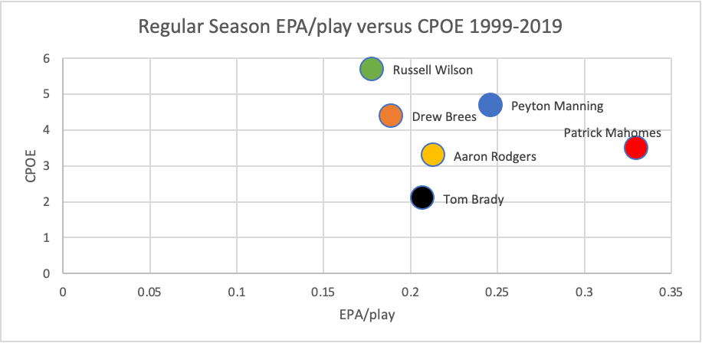
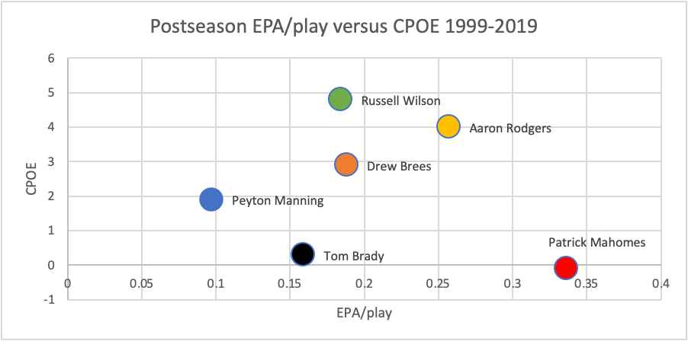
Fig. 2

Steven Vu. (2015, Fall). The Era of Analytics in the NFL: Application of Modern Portfolio Theory. California State University, Long Beach.
Unknown. (n.d.). Tom Brady. Pro Football Reference.
Ibid.
Dave Archibald. (October 25, 2019). Glossary Entry: Expected Points Added. Inside the Pylon.
Joey DiCresce. (October 19, 2021). CPOE Explained. The 33rd Team.
N/A. (n.d.). 2019 Tampa Bay Buccaneers Statistics & Players. Pro Football Reference.
N/A. (n.d.). 2020 Tampa Bay Buccaneers Statistics & Players. Pro Football Reference.
See Figs 1 & 2.
Unknown. (n.d.). Tom Brady Playoffs Game Log. Pro Football Reference.

